## <http://www.dfw.state.or.us/MRP/shellfish/commercial/shrimp/index.asp>

**About the pink shrimp fishery:**

The pink shrimp (Pandalus jordani) is found on sandy and muddy bottoms in 40-150 fathoms along the West Coast of North America. Pink shrimp stocks have historically been centered in Oregon where they have been harvested since 1957. Populations, and consequently fishery landings vary widely from year to year. Landings in 2015 were 53 million pounds and have averaged 30 million pounds per year over the last 30 years. Pink shrimp in Oregon have a maximum life span of four years, natural mortality is high in each year, one and two-year olds typically dominate the commercial catch.

Pink shrimp are harvested via trawling. Most of Oregon’s boats are “double rig” boats; meaning a net is set out from each of the trawl arms and independent of each other.

Oregon shrimp trawl boats typically work between 40 and 125 fathoms (240 to 750 feet) on mud and muddy-sand substrates. Shrimp migrate up off the bottom at night to feed, so vessels don't fish at night. Boats often work together to locate the highest densities and largest sizes of shrimp.

Codends, the terminal end of fishing nets, are emptied into a hopper, from which the catch is carried by conveyor belt for sorting. The catch is then sent to the hold where it is packed in ice for transport. Fishermen deliver the catch into coastal ports for processing, which is done with machines that cook and mechanically peel the shrimp.

Oregon’s pink shrimp resource is annually managed using season and size. Shrimping is open from April 1 to October 31 each year. This season nearly eliminates interference with their reproductive season which typically occurs from November to March. Oregon shrimpers are required to deliver shrimp that average 160 per pound or larger (lower count). Given this regulation regarding size, fisherman move out of areas containing a high percentage of small shrimp.

To assure long term sustainability, management focuses on 1) long term understanding of stock trends (via fishery monitoring, e.g. logbook analysis and dockside sampling) and 2) bycatch reduction (via gear research).

## <http://www.dfw.state.or.us/MRP/shellfish/commercial/shrimp/life_history.asp>

**New recruits:**

In Oregon, pink shrimp larvae are released in early spring, and are planktonic for about 7-8 months before settling to the bottom in the fall. In the plankton, they pass through a series of zoeal growth stages or "instars" before they become recognizable as small shrimp. These young of the year or "zero age" shrimp are often found much higher in the water column than their adult counterparts.

**Maturing shrimp:**

After one-year pink shrimp between 13 and 17 mm in carapace length and are reproductively mature. Oregon’s pink shrimp like many other shrimps are protandrous hermaphrodites, meaning they begin life as a male and over time will change to a female.

Generally, this transition takes place between its 1st and 2nd year, however there are a number of factors that can alter this cycle. For example, in a year that populations are dominated by a 1-year old shrimp, which are normally male, it is common to see the largest 1-year olds mature first as females and become viable for winter reproduction. These are known as “primary females”.

**The next year class**

By the second year of life, pink shrimp are generally all females, between 18 and 25 mm in carapace length. In the fall, female shrimp begin producing eggs, which are carried attached to their abdomen over the winter. A female produces from 1,000 to 3,000 eggs, which hatch in early spring to begin the cycle again.

Three-year-olds, which are exclusively female, only comprise a small percentage of Oregon’s pink shrimp population. Three-year-old pink shrimp are usually between 25 and 29 mm in carapace length. Four-year-olds are not normally found in pink shrimp populations; nearly all three-year-old females will die following their third clutch of eggs hatching.

## <http://www.dfw.state.or.us/MRP/shellfish/commercial/shrimp/landings.asp>

## **Pink shrimp landings/area:**

* Pink shrimp live short lives and annual recruitment levels are linked to environmental conditions, primarily the strength, duration and timing of ocean currents, these two factors result in very high year to year variability of landings.

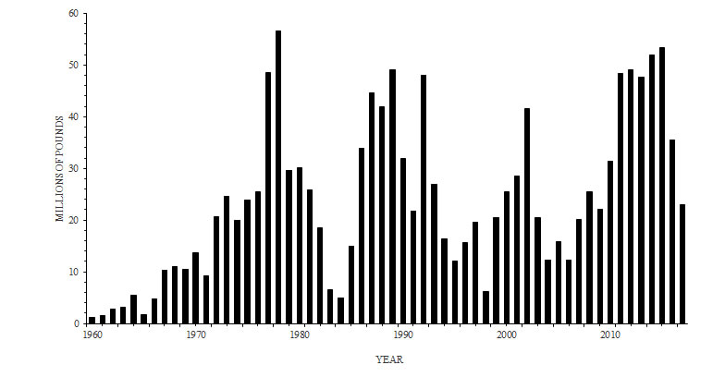

* Pink shrimp are generally fished at depths of 40 to 125 fathoms (240 to 750 feet) in areas of soft substrate. Shaded areas of the map on the right show approximated commercial concentrations of pink shrimp stocks. These data are resultant of fishery logbook information. Dark areas show the approximate minimum aerial extent of shrimp grounds (1984) and the lighter shaded areas show the largest aerial extent observed from 1980-96.

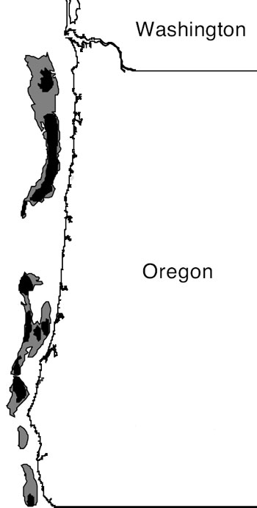

|  |  |  |  |  |
| --- | --- | --- | --- | --- |
| Key regulations that apply to **Oregon** pink shrimp deliveries | | | | |
|  | | Fishing off CA* | Fishing off OR** | Fishing off WA*** |
| Areas | 0-3 miles | No fishing | OR permit needed | No fishing |
| 3-200 miles Key closed areas | Delgada Canyon, Tolo Bank, other closed areas (see [CA regs here](https://nrm.dfg.ca.gov/FileHandler.ashx?DocumentID=123803&inline)) | Nehalem Banks, Daisy Bank, Stonewall Bank, Heceta Bank, Coquille Banks | Grays Canyon (see [WA regs here](http://wdfw.wa.gov/fishing/commercial/shrimp/license_permit_requirements.html)) |
|  |  |  |

## <https://fisheries.msc.org/en/fisheries/oregon-and-washington-pink-shrimp/@@view>

* 2017 Tonnage = 23,947 Tons
* The fishery operates off the coast of Oregon in the western United States and 80-90 vessels are covered under the existing MSC certification. The primary fishing method is otter [trawling](https://www.msc.org/healthy-oceans/sustainable-fishing/fishing-methods-and-gear-types/demersal-bottom-trawls), which derives its name from the "trawl doors" or "otters" which are used to keep the mouth of the net open. The use of bycatch reduction devices are mandatory. Since the discovery of LED lights' effectiveness in reducing bycatch of Eulachon smelt, juvenile flatfish and juvenile rockfish by an additional 78-90%, almost 100% of the fleet have employed such lights on a voluntarily basis.
* The annual catch landed at Oregon ports averages about 11,000 tonnes, with an overall average shrimp size of approximately 3 inches.
* During the fishery’s first 5-year certification period, considerable improvements were made. More and better information for stock assessment has been gathered through the introduction of comprehensive logbooks for recording total catch and discards. Expanded observer coverage, harvest control rules and electronic reporting were also introduced.

# OR and WA Shrimp Surveillance Report – Draft 2 2017.pdf

* Over 52m lbs of pink shrimp were landed on the West Coast in 2016, down from 102m lbs in 2015.
* The total value of the catch declined from over $75m in 2015 to $36m in 2016 (Groth 2017; Wargo 2017; Coates 2017).
* The decline in catch from 2015 to 2016 is largely attributed to the maturation and passing of the historically exceptional 2013 year class of pink shrimp through the fishery.
* Though down from 2015, landings in Oregon exceeded the 20 year average (29.4m lbs from 1996-2015).
* While the number of active vessels (75) and trips (1051) remained similar to recent years, the average price per lb ($0.71) was the 3rd highest on record.
* Much of the 2016 catch in Oregon (87%) was of one-year-old shrimp from the strong 2015 year class that was not detected until June 2015. Given their small size and large volume, fishermen actively avoided or mixed this year class with older/larger shrimp until they grew into legal size by late 2016. These shrimps grew quickly, resulting in good catches toward the end of the 2016 season.
* In Oregon, annual efficiency, measured in catch per unit effort (CPUE) declined to levels similar to those seen in the mid-2000s. The reduced CPUE in 2016 indicates that abundance had declined, likely due to the weak 2014 year class of shrimp (the 2 year olds in 2016). Over the course of 2016, CPUE was steady in the south, while consistently improving in northern areas, as the dominant 1 year old year class grew to legal size.

<http://www.dfw.state.or.us/OARs/05.pdf>

635-005-0630

Fishing Gear-Pink Shrimp Fishery

1. It is unlawful to take pink shrimp for commercial purposes by any means other than trawl net or pots.

(2) It is unlawful to fish with trawl gear for pink shrimp for commercial purposes unless an approved rigid-grate bycatch reduction device is used in each net. A rigid-grate bycatch reduction device uses a rigid panel of narrowly spaced bars to guide fish out of an escape hole in front of the panel, generally in the top of the net. The panel may be hinged to facilitate rolling over a net reel. An approved rigid-grate bycatch reduction device must meet the following criteria:

(a) The exterior circumference of the rigid panel must fit completely within the interior circumference of the trawl net, such that there is no space between the panel and the net that will allow a 110 mm sphere to pass beyond the panel, into the terminal area of the codend;

(b) None of the openings between the bars in the rigid panel may exceed 0.75 inches.

(c) The escape hole must, when spread open, expose a hole of at least 100 square inches; and

(d) The escape hole must be forward of the rigid panel and must begin within four meshes of the furthest aftpoint of attachment of the rigid panel to the net.

(3) It is unlawful to fish with trawl gear for pink shrimp for commercial purposes unless footrope lighting devices that have been approved by the Department are used in each net. A list of approved footrope lighting devices is available from the Department. Footrope lighting devices must meet the following criteria:

(a) Lighting devices must be operational

(b) Lighting devices must be securely attached within 6 inches of the forward leading edge of the bottom panel of trawl netting; and

(c) Each trawl net must have a minimum of five lighting devices, spaced 4 feet apart in the central 16 feet of each net.

(4) All bycatch reduction devices, codends, and footrope lighting devices used for trawl fishing for pink shrimp must be readily accessible and made available for inspection at the request of an authorized agent of the state. No trawl gear may be removed from the vessel prior to offloading of shrimp.

(5) It is unlawful to modify bycatch reduction devices or footrope lighting devices in any way that interferes with their ability to allow fish to escape from the trawl.

Commercial Pink Shrimp Landings. (2017). Retrieved March 22, 2018, from <http://www.dfw.state.or.us/MRP/shellfish/commercial/shrimp/landings.asp>